**September Birthdays**

2 Carl Hardwick

3 Rose Morris

4 Jimmy Blunt

Adna Fainter

5 Shirley Johnson

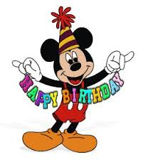6 Brian Anders

8 Monica Campbell

9 Mintcy Maxham

10 Carolyn Inman

11 Robert Hicks

12 Clarissa Clarke

14 Robert Elium, Jr.

Joel Weaver

15 Elizabeth Daugherty

Jody Underwood

16 John Forster

17 Jerry Lease

18 Robert Bennett

Sarah Stables

19 Thomas Evans

Linda Stinnett

20 Doris Wilkerson

21 Naomi Levin

Beryl Martin

22 Eleanor Maxham

23 Blair Gunter

Mary Walker

24 Brianna Abbott

Brandi Tinsley

Betty Williams

26 Jessah Klein

Sharon Mayhew

28 Kendall Gunter

Janice Harden

29 Beverly Franklin

Chet Walker